Thesis Status Quo

Date: 27.05.2019

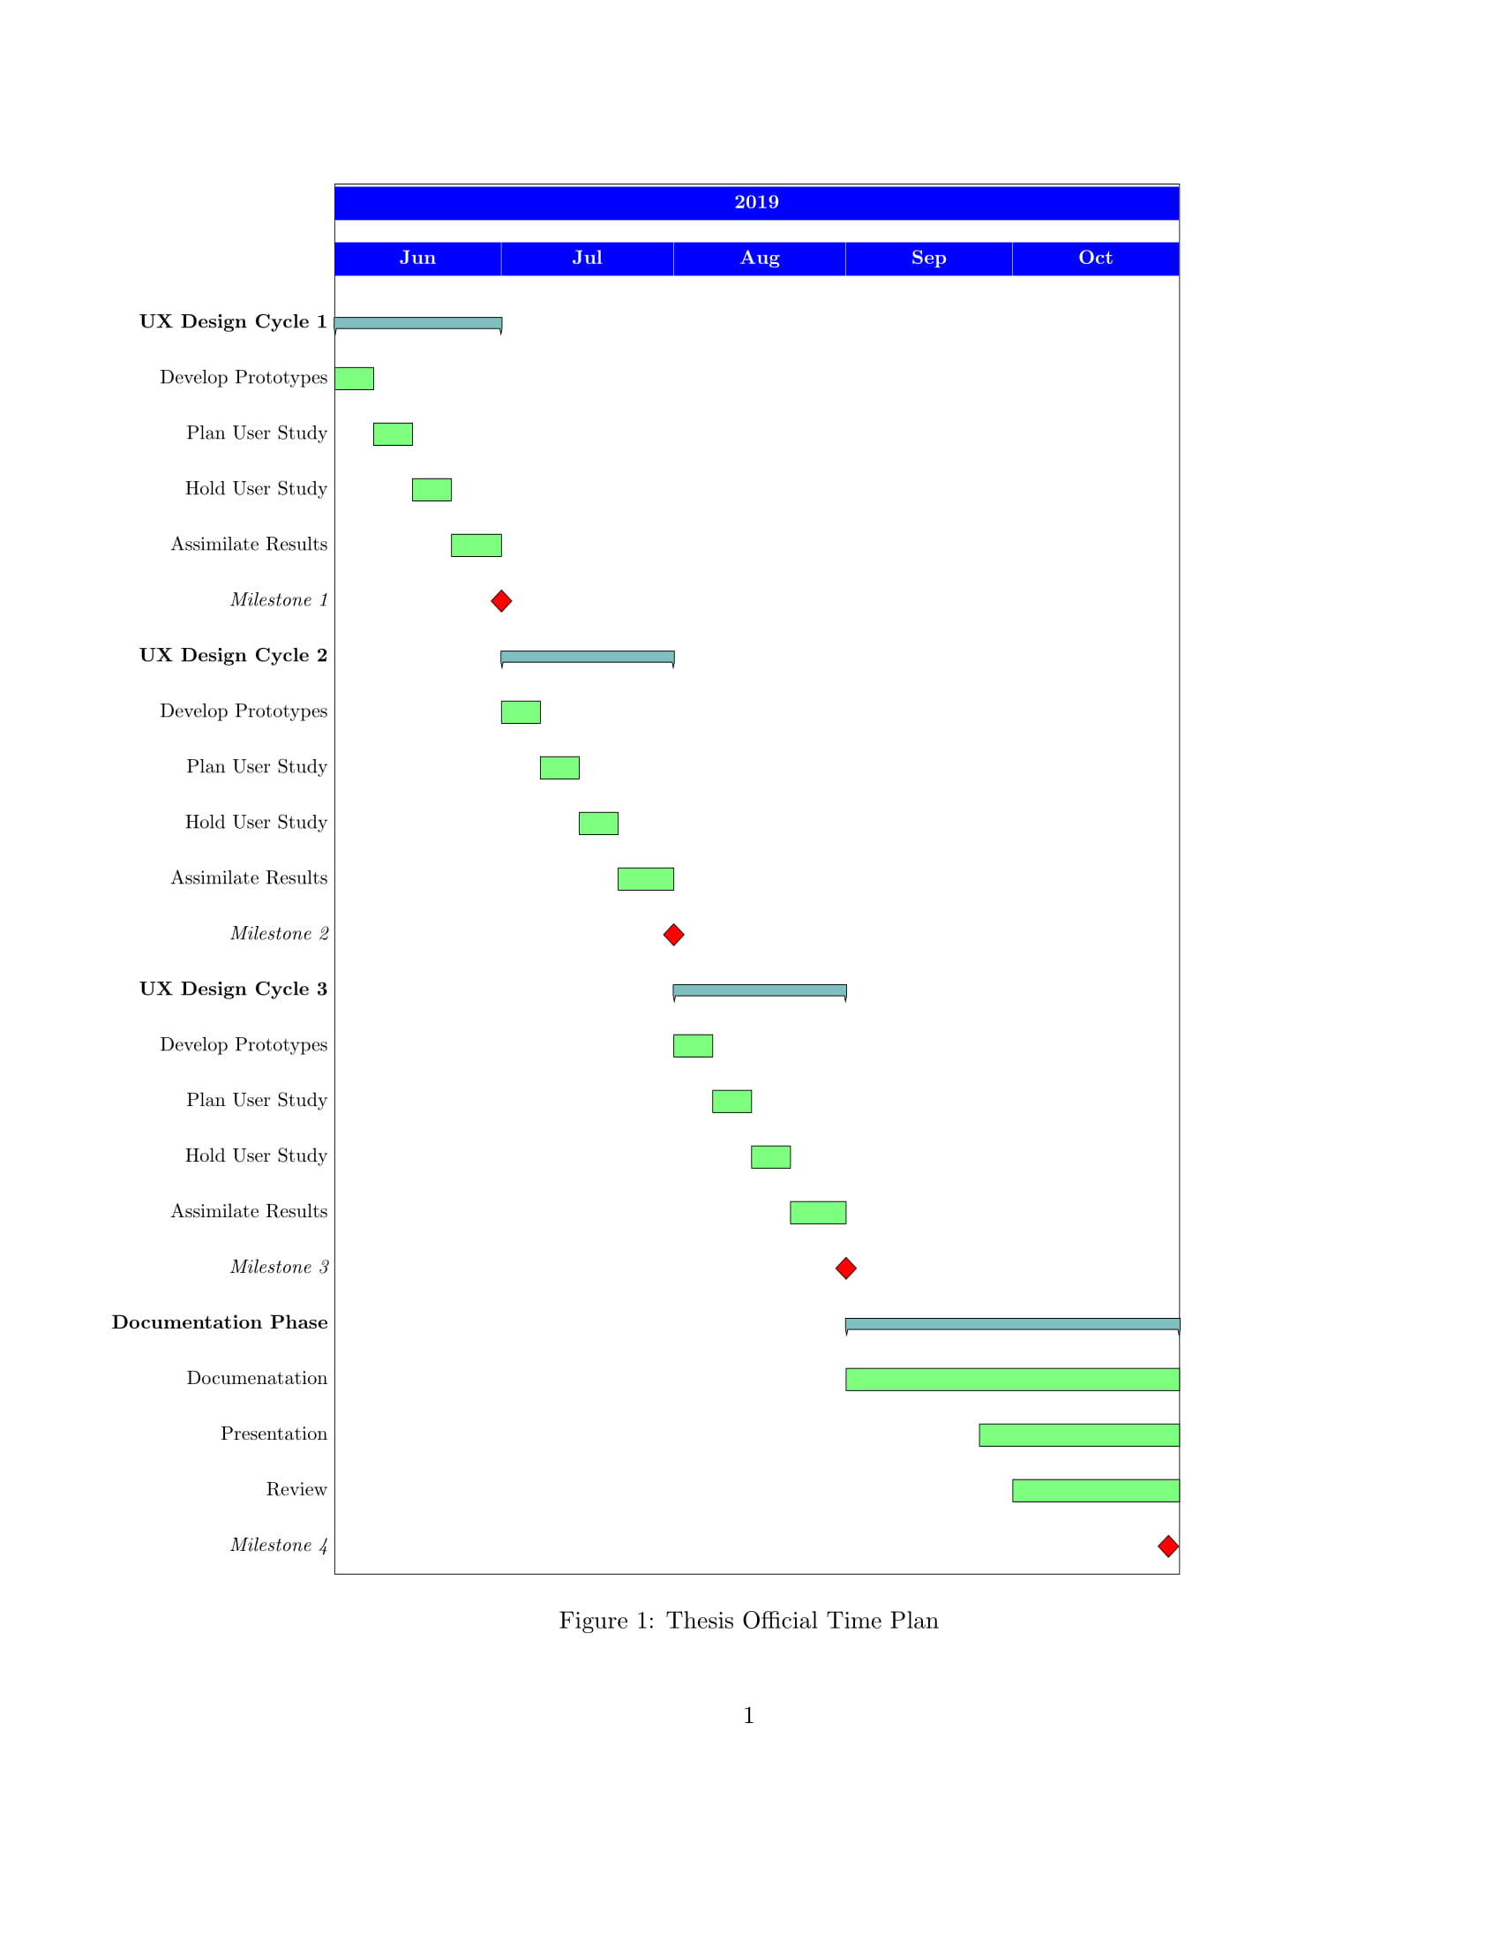

In progress…

done

done

done